**Table of Contents**

1. Executive Summary 3

1.1 Project Overview 3

1.2 Purpose and Scope of this Specification 3

2. Product/Service Description 3

2.1 Product Context 3

2.2 User Characteristics 3

2.3 Assumptions 3

2.4 Constraints 4

7.1 Dependencies 4

11. Requirements 4

11.1 Functional Requirements 4

11.2 Security 5

11.2.1 Protection 5

11.2.2 Authorization and Authentication 5

11.3 Portability 5

12. Requirements Confirmation/Stakeholder sign-off 5

13. System Design 5

13.1 Algorithm 5

13.2 System Flow 5

13.3 Software 6

13.4 Hardware 6

13.5 Test Plan 6

13.6 Task List/Gantt Chart 7

13.7 Staffing Plan 7

# Executive Summary

## Project Overview

This project is about using robotics to complete a series of tasks. The intended audience is the classroom in which the project was given and specifically, my classmates/teacher. We also could use these robots to introduce new people into coding when everything is fully functional; once people see how cool and fulfilling it is to program robots to move in a controlled environment, we can attract more attention to software/computer programming.

## Purpose and Scope of this Specification

The intended purpose of this project is to follow a series of steps and processes given to us by our instructor. This includes:

* Following a rectangular path (with proper accuracy and an appropriate speed)
* Moving around the course while talking to the user (also trying to change color/talk to the user)
* Keeping a consistent speed while traversing around the course and following all steps in the Sphero program

# Product/Service Description

The general factors that affect our product is the programming of the robot itself and how computers utilize this hardware. We also use the website Sphero.edu and a Bluetooth connection to run block code (to make the robot function the way we want). Our robots are in new models (Bolt), but overall, with proper computer/phone software, a Sphero robot, and a stable Bluetooth connection this project should be possible.

## Product Context

Our robots can be compared to other robot services/products, due to the simplistic nature of how easy it is to connect. There are many other robotic sites that come with purchasable robots/machines to control, however, the robots we are using, and the user interface run by Sphero.edu is a completely independent service. The website is run over Bluetooth connection and is very easy to use when a Sphero robot is present; the site they use as well Is their own in terms of the block code and doesn’t rely on other sites such as code.org.

## User Characteristics

* Student/Classmate – Ages – 18 – 23 – College Education Level – Software/Computer Science Expertise – First to second year work in robotics and programming.
* Teacher – Age (30 – 80) – Masters/Bachelors/PhD level Education – Software/Computer Science expert – Multiple years working in the field of robotics/software development.
* Regular consumer – Age (5 – 70) – Any education level – Any major/profession – New or existing knowledge of programming/software.

## Assumptions

Any of the following assumptions will affect the requirements, a little description to explain each can be used as help too.

* Use of a windows computer (This will not affect the robots’ capabilities, but the sensory data portion of Sphero.edu will be affected. It is easier to use this website/app on Mac)
* User Expertise (This will not be a complete deal breaker, any knowledge range can be used with the robot, but some functions/code will appear difficult and trying to make the robot complete a certain task will be harder with less knowledge)
* Chromebooks and iPad Devices can be used with the Sphero robots (Recommended that you use Windows computers or MacBook devices with the capabilities of ios14 and up)

## Constraints

* Parallel operation with an old system (IOS 14 and below + Windows 12 and below)
* Room availability (the product will be unable to complete all asked tasks without proper preparation times. If we are unable to meet at least 3 times, the result will show)
* Access to the Sphero Website, unprofessional management, and faulty security (all these factors will prohibit the best possible work achieved and if present can be detrimental)
* Criticality of the application (If Sphero itself was to shut down or malfunction the work process can be affected)
* System resources (Bad battery usage of our main computer, the failure to bring our work devices, and limited storage to store our documents)

## Dependencies

* The workspace reception being effective enough to run the program code
* The Wi-Fi adapter/Intel graphics cards of our computers (Having accessibility to Apple’s EN0, and Mac OS software)
* Robot designed by Sphero or another robot with the capabilities to run through the main website

# Requirements

**Priority Definitions**

* Priority 1 – Must have an established Bluetooth/Wi-Fi connection with Sphero robot and website
* Priority 2 – Sufficient computer with adequate processor, CPU, and graphics cards (should be a Mac OS system for best production/accessibility to sensory data and graphs); Mac is not needed, Windows is sufficient but does not give entire access to website
* Priority 3 – More advanced type of robot, course picture/walkthrough, Google documents that list every step along the testing process (can be done with the “notes” portion of the Sphero website). In our case we used Microsoft Word and draw.io to document all our progress.
* Priority 4 - Calibrate the machine in order to follow directions of the course
* Priority 5 - Test robot enough times to perfect the course, change color, and talk to user
* Priority 6 - Record video of Sphero robot traversing the course accurately

## Functional Requirements

| **Req#** | **Requirement** | **Comments** | **Priority** | **Date Reviewed** | **SME Reviewed / Approved** |
| --- | --- | --- | --- | --- | --- |
| ENDUR_01 | Establish a Bluetooth/Wi-Fi connection | We need this in relation to controlling the actual robot and interacting with the main website. | First priority | 10/24/23 | 10/24/23 |
| ENDUR_02 | Having a Mac OS computer be our main source of operations | This is necessary due to access to the sensory data chart and for more conclusive evidence that our program runs smoothly. | Second priority | 10/25/23 | 10/26/23 |
| ENDUR_03 | More advanced type of robot and complete access to the course we will run our robot. | This is more of a want in our robotic project. We can work with any type of Sphero robot, but the entire process is made easier with more advanced robots. | Third priority | 10/27/23 | 10/29/23 |
| ENDUR_04 | Calibrate the machine in order to follow directions of the course | We have to use the aiming mechanic within the Sphero app and proper degree measurements for a rectangular shape | Fourth priority | 11/3/23 | 11/4/23 |
| ENDUR_05 | Test robot enough times to perfect the course, change color, and talk to user | This proved tricky, but we mastered it after several test runs | Fifth priority | 11/4/23 | 11/4/23 |
| ENDUR_06 | Record video of Sphero robot traversing the course accurately | We needed at least two people to run the robot and record the video (Jalen and Jimmy) | Sixth priority | 11/5/23 | 11/5/23 |

## 

## Security

### Protection

* Ensuring only group members can access and edit repository contents.
* Sphero must be within range of the host computer to operate remotely.
* Programs used for the system must be trusted and free of malware and whatnot.

### Authorization and Authentication

* Each group member must accept the invitation to the proper repositories to be given permission to edit repository contents.
* Login confirms the identity of the person (with the correct username and the correct password) and grants access to the site under their respective username.

## Portability

* The Sphero application provides its own block coding program for robot operation.
* Each of the three group members mainly uses a different operating system.
  + Windows, MacOS, and ChromeOS are all compatible with Sphero to different extents.
* Computers must connect with the robot and follow the block code effectively regardless of the operating system used.
* The course is a rectangular track marked by blue duct tape on the floor of a classroom of an appropriate size.

# Requirements Confirmation/Stakeholder sign-off

|  |  |  |
| --- | --- | --- |
| **Meeting Date** | **Attendees (name and role)** | **Comments** |
| 10/19/2023 | Jalen (group member), Jared (group member), Jimmy (group member) | confirmed to 2.5, 3, and 3.1 on SDD |
| 10/24/2023 | Jalen (group member), Jared (group member), Jimmy (group member) | confirmed to 3.1, 2.5, 3, and staffing plan on SDD |

# 

# System Design

## Algorithm

**Rectangle:**

* Change main LED to green
* Speak “Ready, Set, Go”
* Roll 0 degrees at 80 speed for 12.25 seconds
* Roll 90 degrees at 80 speed for 6.6 seconds
* Roll 180 degrees at 78 speed for 12.5 seconds
* Roll 270 degrees at 86 speed for 6.3 seconds
* Roll 0 at 39 speed for 6 seconds
* Change main LED to red
* Speak “I’m done and I need water”

## System Flow

<https://drive.google.com/file/d/1oh9afH6ERkWc8qkbU5fxsHZLpippYXFt/view?usp=sharing>

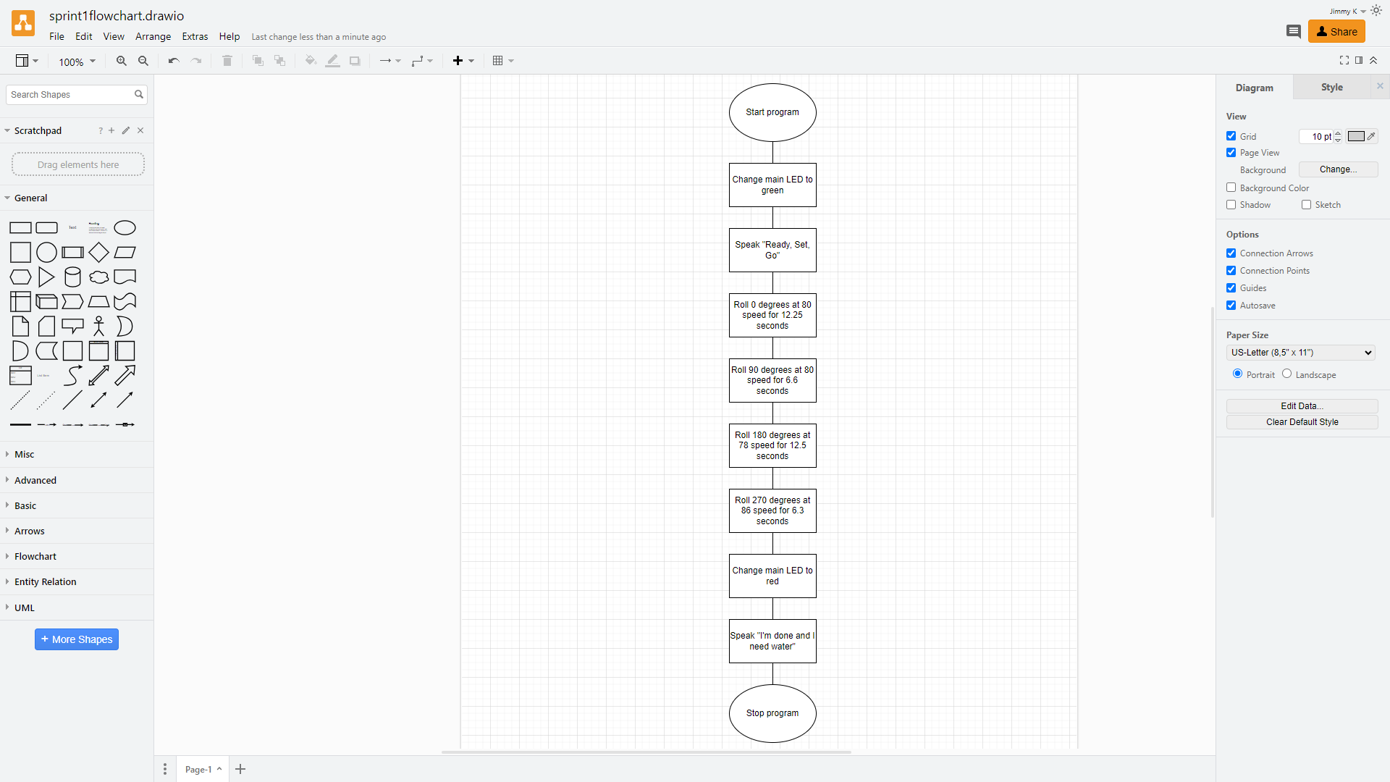

## Software

Sphero 6.6.0 | Operates on Java | Written to give sphere-shaped robots the ability of motion by drawing paths through the app via block code.

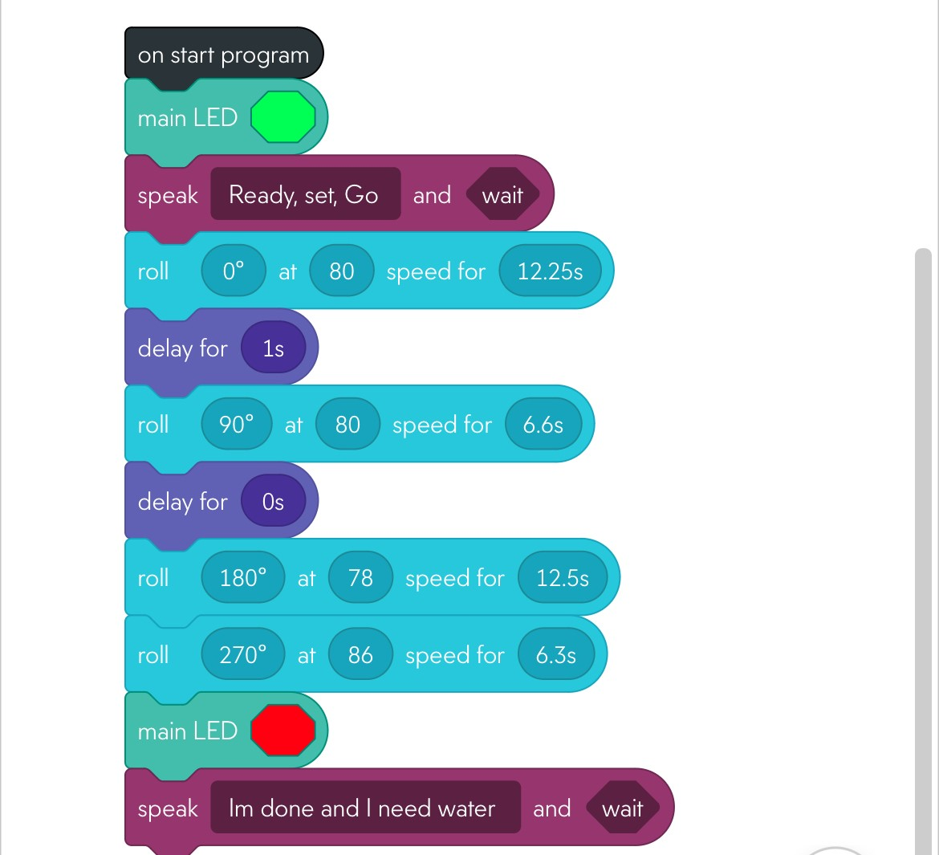

## Hardware

MacBook Pro 15-Inch, 2019 | Processor 2.3 GHz 8-Core Intel Core i9 | Graphics Intel UHD Graphics 630 1536 MB | Memory 16 GB 2400 MHz DDR4 | MacOS Ventura 13.5.2

## Test Plan

| **Reason for Test Case** | **Test Date** | **Expected Output** | **Observed Output** | **Staff Name** | **Pass/Fail** |
| --- | --- | --- | --- | --- | --- |
| Alignment at starting point and speech saying “ready, set, go” | 10/29/23 | Slightly skewed to the left or right | Skewed right | Jalen, Jared, Jimmy | Fail |
| Alignment at starting point and speech saying “ready, set, go” | 10/29/23 | Slightly skewed to the left or right | Skewed right | Jalen, Jared, Jimmy | Pass |
| First turn in obstacle | 10/29/23 | Followed design set by course | Followed course outline | Jalen, Jared, Jimmy | Pass |
| Second turn in obstacle | 10/29/23 | Followed design set by course | Followed course outline | Jalen, Jared, Jimmy | Fail |
| Second turn in obstacle | 10/29/23 | Followed design set by course | Followed course outline | Jalen, Jared, Jimmy | Pass |
| Third turn matching first starting line | 10/29/23 | Followed design set by course | Followed course outline | Jalen, Jared, Jimmy | Pass |
| Last turn in obstacle | 10/29/23 | Followed design set by course | Followed course outline | Jalen, Jared, Jimmy | Fail |
| Last turn in obstacle | 10/29/23 | Followed design set by course | Followed course outline | Jalen, Jared, Jimmy | Pass |
| Arrived at starting point, changed color to red, and spoke “I’m done and I need water” | 10/29/23 | Followed design set by course | Followed course outline | Jalen, Jared, Jimmy | Pass |

## Task List/Gantt Chart

<https://onedrive.live.com/edit.aspx?resid=989AFAE5454A455B!222&ithint=file%2cxlsx&wdo=2&authkey=!AJI09z-bLqPmW8g>

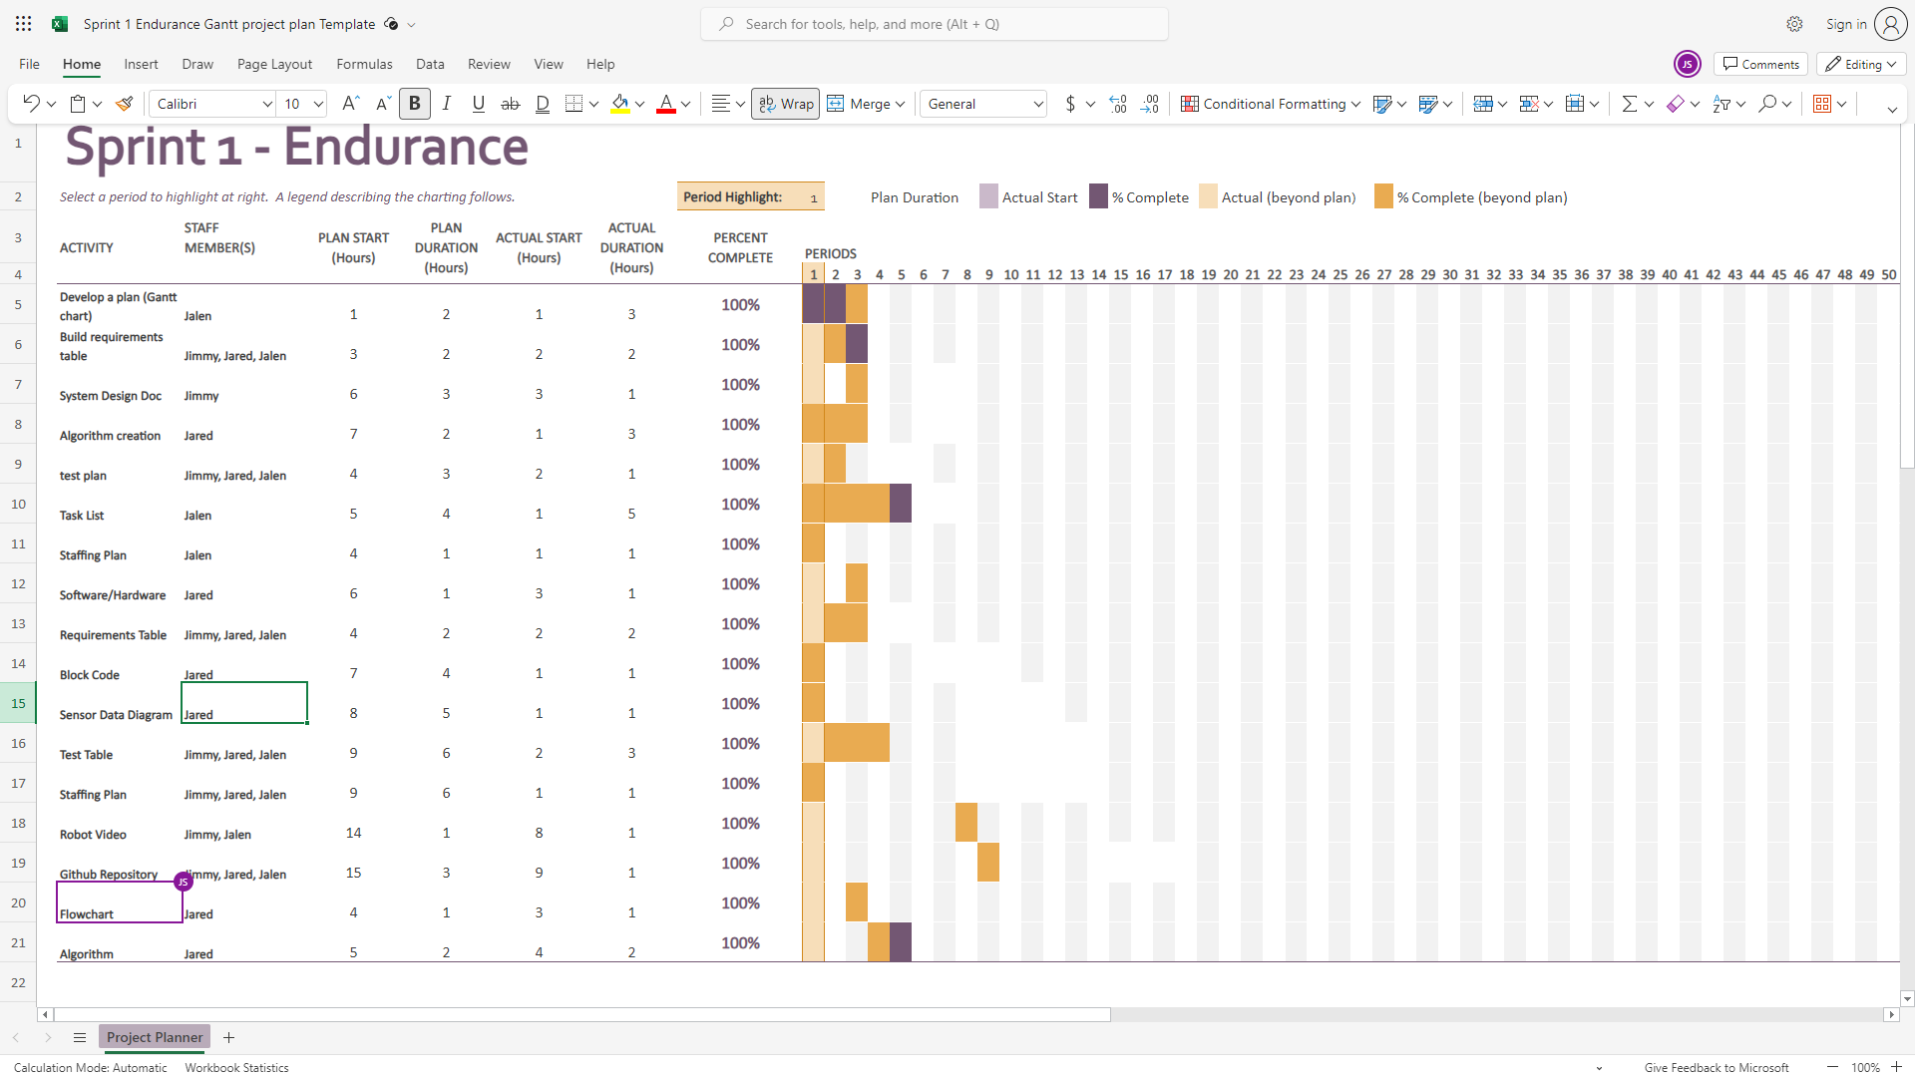

## Staffing Plan

| Name | Role | Responsibility | Reports To |
| --- | --- | --- | --- |
| Jalen | Project Manager | * Complete Gantt Chart * Complete Staff Plan * Complete block code and sensory data | Group |
| Jimmy | Repository Host | * Hand in SDD * Robot video | Group |
| Jared | Programmer | * Requirements and requirements table * Algorithm and flowchart | Group |